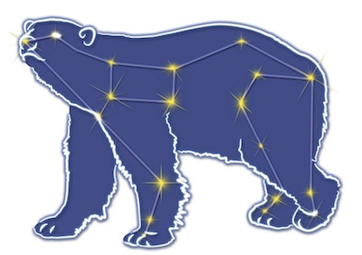
Great Bear Petroleum Operating LLC
A New Direction for the Last Frontier
601 W. 5th Ave., Suite 505, Anchorage, AK 99501
Phone: (907) 868-8070, Fax: (907) 868-3887

July 27, 2011

Ms. Cathy Foerster, Chair
Alaska Oil and Gas Conservation Commission
601 West 5th Ave., Suite 505
Anchorage, Alaska 99501

RE: Weekly Report of Operations
Great Bear Petroleum: Alcor #1 (PTD # 212-057)

Dear: Ms. Foerster,
This is a report of Great Bear Petroleum’s well operations on the Alcor #1 for the period July 20 through July 26, 2012, inclusive.

July 20, 2012 8,674’ MW 9.4 ppg Vis 71 sec Incl 8.67˚
Wait for ball to drop to core bbl. Core from 8,640’ to 8,674’. Pump various sweeps past bit to try to improve ROP.

July 21, 2012 8,676’ MW 9.4 ppg Vis 80 sec Incl 8.67˚
Core from 8,674’ to 8,676’. Break off with 5K lbs overpull and POH. LD BHA and core. 32.15’ of core recovered. Test BOP’s. Test witness waived by AOGCC’s Bob Noble.

July 22, 2012 8,676’ MW 9.4 ppg Vis 75 sec Incl 8.67˚
Finish testing BOPE. M/U 6-1/8” drilling BHA and RIH. At 8,610’ lost signal from MWD. Attempt to regain – no success. POH.

July 23, 2012 8,799’ MW 9.4 ppg Vis 67 sec Incl 10.12˚
Cont POH. Change out MWD tool. RIH. MAD pass 8,640’ to 8,667’. Slide drill 8,676’ to 8,799’.

July 24, 2012 9,208’ MW 9.7 ppg Vis 57 sec Incl 8.67˚
Drill 6-1/8” hole 8,799’ to 9,186’. Gas units rising and cutting mud weight. Weight up system to 9.6 ppg. Still circulating up gas-cut mud. Weight system up to 10.0 ppg. Drill 9,186’ to 9,197’. Monitor well, still has gas bubbling in mud. Weight up to 10.1 ppg and drill 9,197’ to 9,208’ while weighting up to 10.2 ppg.

July 25, 2012 10,015’ MW 10.6 ppg Vis 54 sec Incl 3.48˚
Drill 6-1/8” hole 9,208’ to 9,435’ while gradually weighting up mud from 10.2 ppg to 10.5 ppg to control gas. Drill 9,435’ to 10,015’ (core point) while gradually weighting up mud to 10.6 ppg. Mud losses to hole steady at 10 bph. C&C mud, prepare to displace hole with 11.2 ppg mud to POH for core bbl.

July 26, 2012 10,015’ MW 11.2 ppg Vis 53 sec Incl 3.48˚
C&C mud. Displace 10.6 ppg mud from hole with 11.2 ppg mud for tripping out. Monitor well – static. POH to 9,380’, monitor well – static. POH, handle BHA. MU 90’ coring assy and RIH. Static mud losses 8 bph.

If you have any questions or require additional information, please contact me at 264-6114 or 250-3113.

Sincerely,

For GREAT BEAR PETROLEUM OPERATING LLC

Bill Penrose

Drilling Manager
SolstenXP Inc.

cc: Clark Clement – Great Bear

